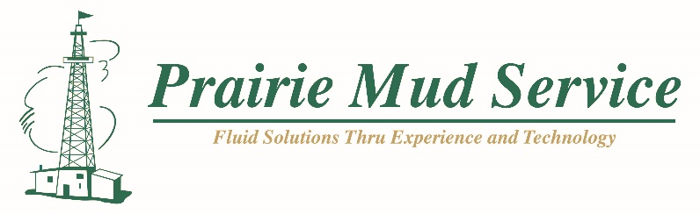

HEALTH & SAFETY POLICY
WHAT IS HEALTH AND SAFETY?
Health and Safety are an integral part of the daily operations Prairie Mud Service. Health and Safety measures are implemented to protect our employees, customers, property, the environment, and the public.

WHY IS SAFETY IMPORTANT TO THE COMPANY?
There are many costs to workplace incidents and unsafe work practices with the greatest costs being human costs. By protecting our employees, we are also protecting their families, friends, fellow workers, management, the public, and the environment from the far-reaching effects of hazardous conditions and/or workplace incidents.

In addition to protecting lives our safety program contributes to employee morale and pride due to our employees participating in identifying hazards, identifying safety needs, developing safe work practices and safe work procedures.

WHAT ARE THE ALTERNATIVES TO SAFETY?
Employees, contractors, and sub-contractors who knowingly violate safety rules may face disciplinary action, dismissal, or legal action. Visitors may also face legal action if they knowingly disobey safety rules. In addition, the company may face legal action and fines for violations of regulatory requirements. Those individuals who do not fulfill their safety responsibilities will become accountable for any problems their negligence creates and may be liable under law.

WHO IS RESPONSIBLE?
Everyone employed by Prairie Mud Service are responsible for maintaining the safety program. Senior Managers, Managers and Supervisors are responsible for supporting and enforcing the entire safety program, identifying safety needs, communicating safety hazards, investigating hazardous conditions and incidents, providing training, supplying appropriate personal protective equipment, ensuring all equipment is properly maintained and meets legislated safety standards. Their role is supported by the input from all employees on every level within the company.

All company employees and others on company worksites are responsible for obeying all safety rules, following recommended safe work procedures, wearing and using personal protective equipment when required, participating in safety training programs and informing supervisors of any unsafe work conditions. Everyone has the right and responsibility to refuse to do work when unsafe conditions exist.

By fulfilling our Health and Safety responsibilities everyone who works for Prairie Mud Service will share the benefits of a safe workplace.
Ray Frehlick
President

